OT Sistematik Botanik Dergisi
24, 2, - , 2017 – ISSN 1300-2953

A new remarkably Silene L. species (Caryophyllaceae)
from Bingöl provinces, Turkey

Şinasi YILDIRIMLI* & Ömer KILIÇ**

*University of Hacettepe, Science of Faculty, Department of Biology
Division of Botany 06532 Beytepe-Ankara-Türkiye
ot@hacettepe.edu.tr
**Technical Science Vocational High School, Bingöl University, Bingöl 12000, Turkey
omerkilic77@gmail.com

Abstract
Perennial S. magenta Yıld. & Kılıç (Caryophyllaceae) are described and illustrated as new species from Bingöl, east Turkey. The distributions of the new and closely related species are mapped. S. magenta is closely related to S. hamzaoglui and S. phyrigia, respectively.
Key Words: S. magenta, Caryophyllaceae, Bingöl, Turkey

Introduction

Silene L. is one of the largest flowering plant genera in the world with c. 750 species with the generality of them distributed in Mediterranean region (1). Since 1967, 29 new taxa have been described from Turkey, is one of the main centres of diversity for the genus, is represented by 148 species (2-21). It is represented by 31 sections and 144 taxa, 42 % are endemic (From Fırat & Yıldız) (22).

The authors collected interesting specimens from the Tunceli and Bingöl provinces of east Turkey during a field trip in the summer of 2015-2016, respectivly. After morphological research, these specimens of Silene have been compared to many specimens of supposedly related species in the Herbaria of ANK, GAZI and HUB in Ankara. and consulting the numerous relevant literature, it was concluded that these specimens of Silene represent as new species to science.

Taxonomic Treatment

Caryophyllaceae

Silene magenta Yıld. & Kılıç, sp. nov., figures 7-14
Perennial herb no sterile shoots at the base. Stems 55-70 cm long including inflorescence, erect, terete, fragile, green to purplish, 1-3-paired leafy, usually glabrous to puberulent at base, glabrous to glandular-punctate, viscid at inflorescence. Nodium swollen. Leaves opposite, basal ones 7-17 x 0.5-1.4 cm, linear-oblanceolate, petiolate, attenuate at base, 3-nerved; stem leaves decreasing upward, 3-15 x 0.4-1.4 cm, linear-lanceolate, attenuate at base, acute at apex, puberulent, 3-nerved. Inflorescence 20-35 x 7-12 cm, paniculate-compound cymes, usually glabrous to glandular-punctate, viscid, (22)-31-35-flowered. Peduncules 3-5 cm long, erect, glabrous. Bracts 2, 40 x 3-4 mm, broadly linear, lowermost ones, 3 x 0.5 mm uppermost ones, semiconnate, linear, green-purplish, densely pilose at base and scrious margins, sparsely pilose and herbaceous at margins, acute at apex. Pedicels c. 2-5 mm long, erect, glabrıus. Bracteoles 2, 2-3 mm long, densely pilose at base, sparsely pilose at margins, decreasing as bracts. Calyx 6-8 x 3-4 mm, obconic, united, tube 5 mm, teeth 1 mm, ovate-obtuse with white scarious and shortly pubescent or pilose at apex, purple, 10-nerved, along on the veins glabrous. Corolla 8-15 x 0.5-2 mm, magenta. Petal’s claw 5 mm, scarious, pilose, 3-brownish nerved; limb c. 5-10 mm, magenta, bifid, glabrous. Stamens c. 3 mm long expanded at base, anthers c. 0.5-1.5 x 0.25-0.75 mm, light brown, versatile, glabrous. Styles 3, 7-8 mm. Anthophores c. 1-2 mm. Capsules 5-6 x 3-5 mm, ovale, glabrous, yellow.
Type. Turkey. B8 BİNGÖL: after the road separation Kiğı, Karakoçan-Sancak, 6. km, road edge, slope, 1450 m, 24.05.2017, Ş. Yıldırımlı 43367 & Ö. Kılıç (holo. Yıldırımlı Herbarium; iso. ANK, EGE, GAZİ, HUB, PAMUK, Yıldırımlı Herbariums).
Endemic. Anatolia-Turanian element.
Close to Silene hamzaoglui Budak but plants no sterile shoots at the base (with sterile shoots at the base); stems 55-70 cm long (not 35-55 cm), 1-3-paired leafy (not densely leafy), and glabrous to puberulent (not hirsute); leaves puberulent (not hirsute and ciliate); bracts pilose at margins (not canescent); bracteoles 2-3 mm long (not 5-8 mm); calyx glabrous along on the veins (not sparsely canescent along on the veins); flowers magenta (not pink); petal’s claw margins pilose (not ciliate); anthophores 1-2 mm long (not 2.5-3.5 mm); capsules c. 6 mm long (not 7-11 mm) and S. phyrigia Boiss. but stem leaves linear-lanceolate (not linear), inflorescence many flowered (not few flowered), calyx glabrous and shortly pilose at apex (not completely glabrous), petals magenta (not white).
Etymology. The species epithet is derived from a light purple, purplish-red, or pinkish purple colour of flowers.

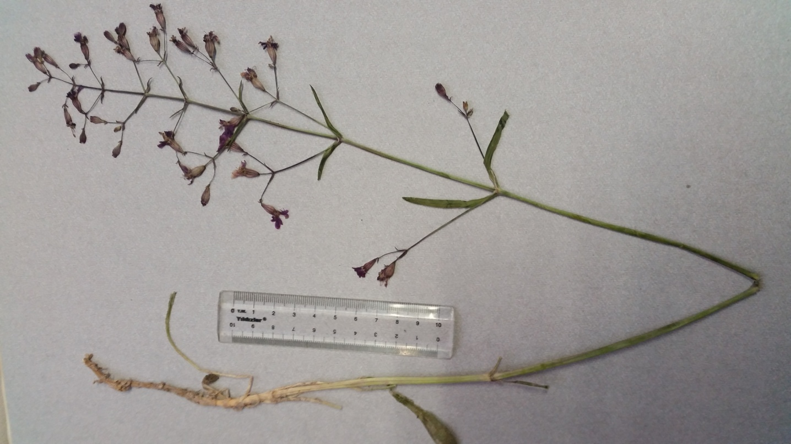
Figure 7. Silene magenta, habitus, Ş. Yıldırımlı 43367 & Ö. Kılıç (holotype)

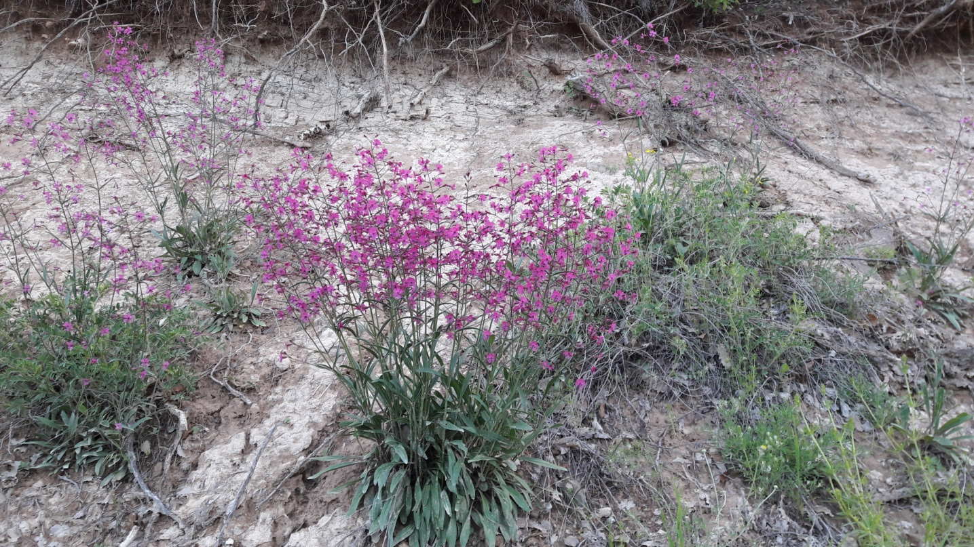

Figure 8. Silene magenta, habitus, Ş. Yıldırımlı 43367 & Ö. Kılıç (holotype)
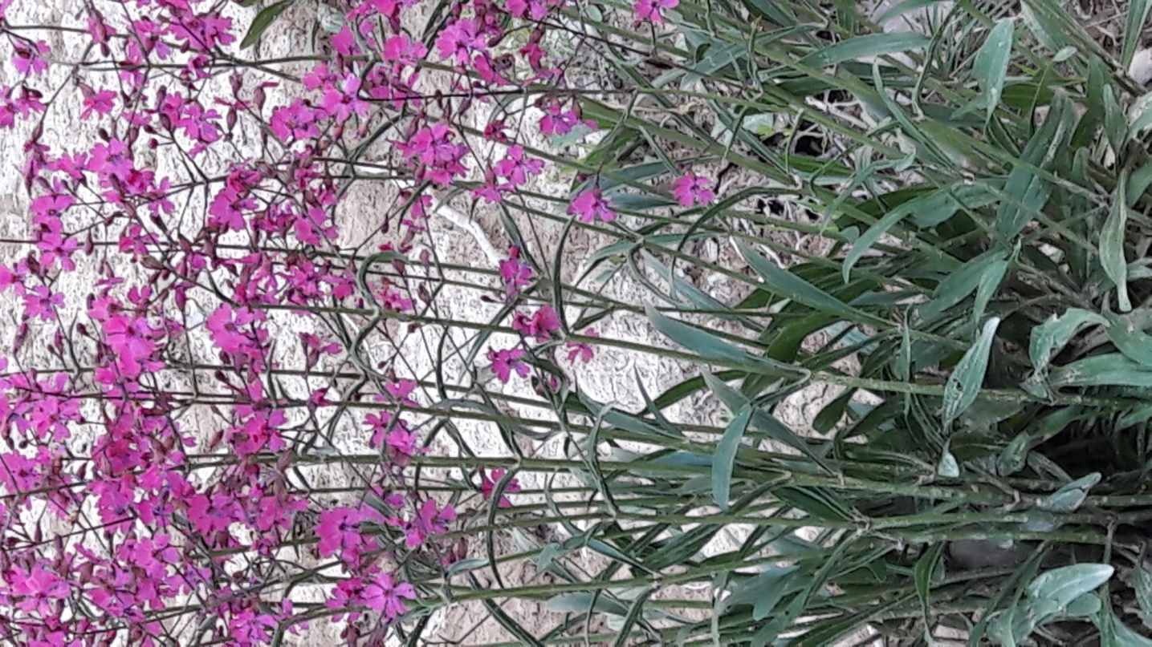
Figure 9. Silene magenta, habitus, Ş. Yıldırımlı 43367 & Ö. Kılıç (holotype)
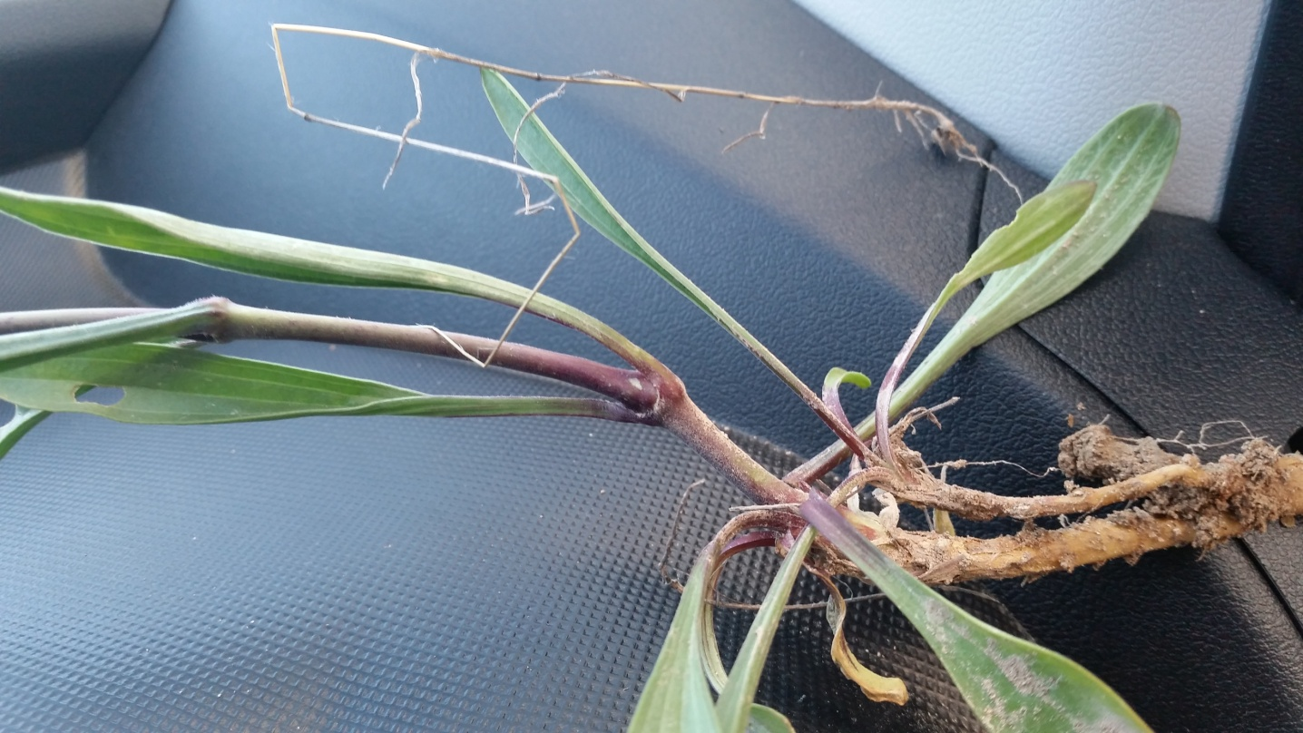
Figure 10. Silene magenta, basal leaves, Ş. Yıldırımlı 43367 & Ö. Kılıç (holotype)

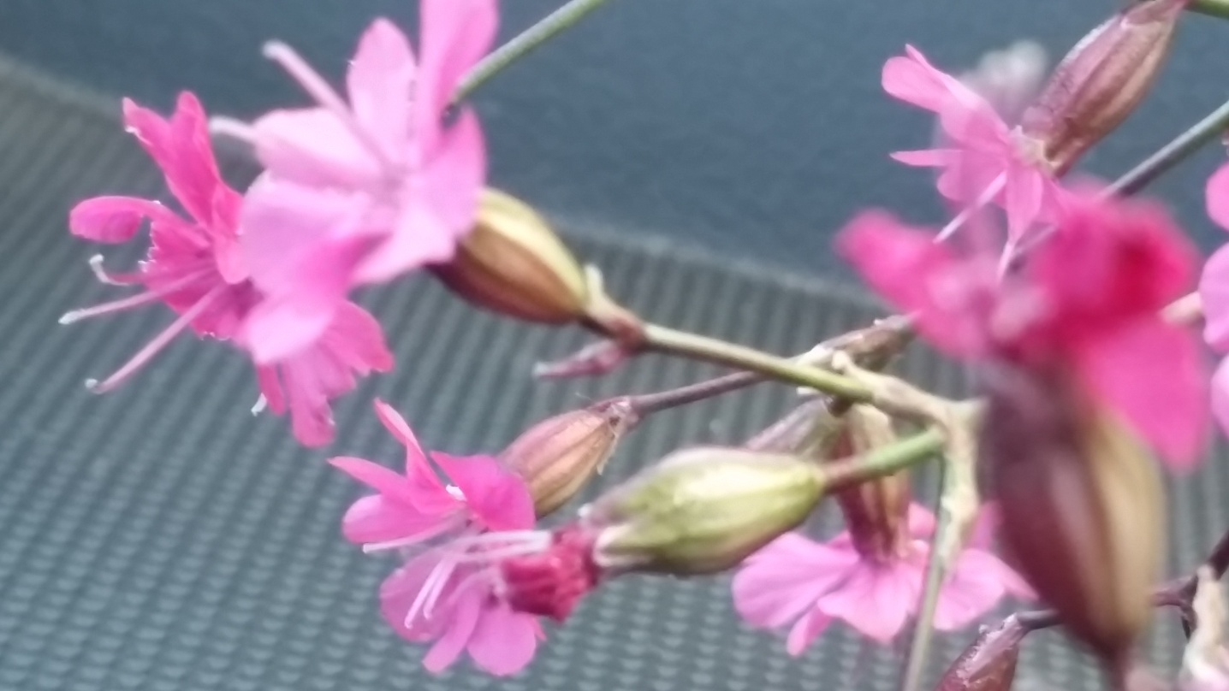
Figure 11. Silene magenta, inflorescence, Ş. Yıldırımlı 43367 & Ö. Kılıç (holotype)

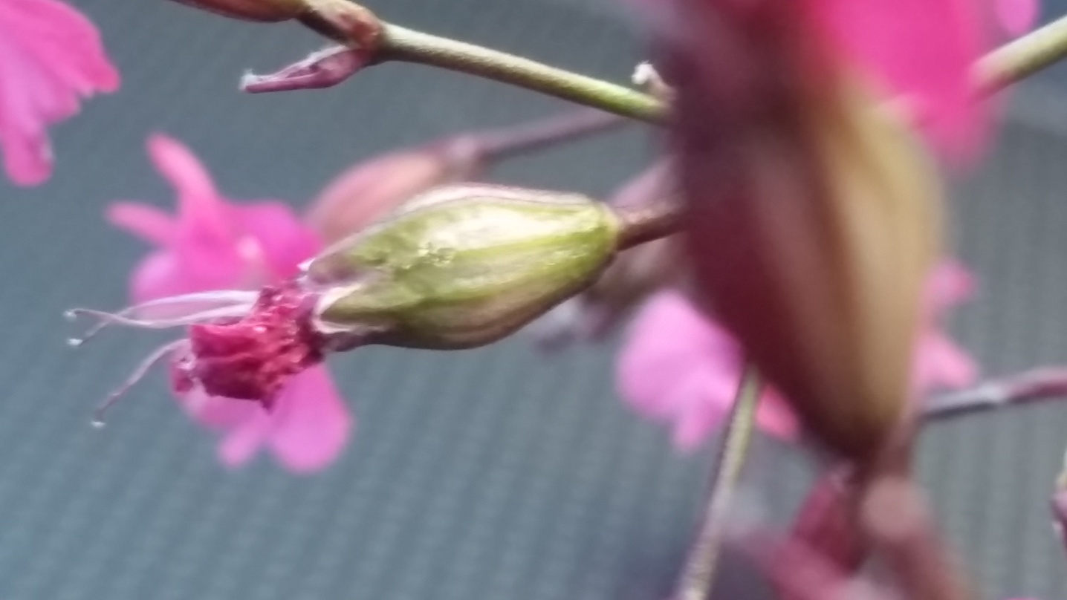

Figure 12. Silene magenta, calyx, Ş. Yıldırımlı 43367 & Ö. Kılıç (holotype)
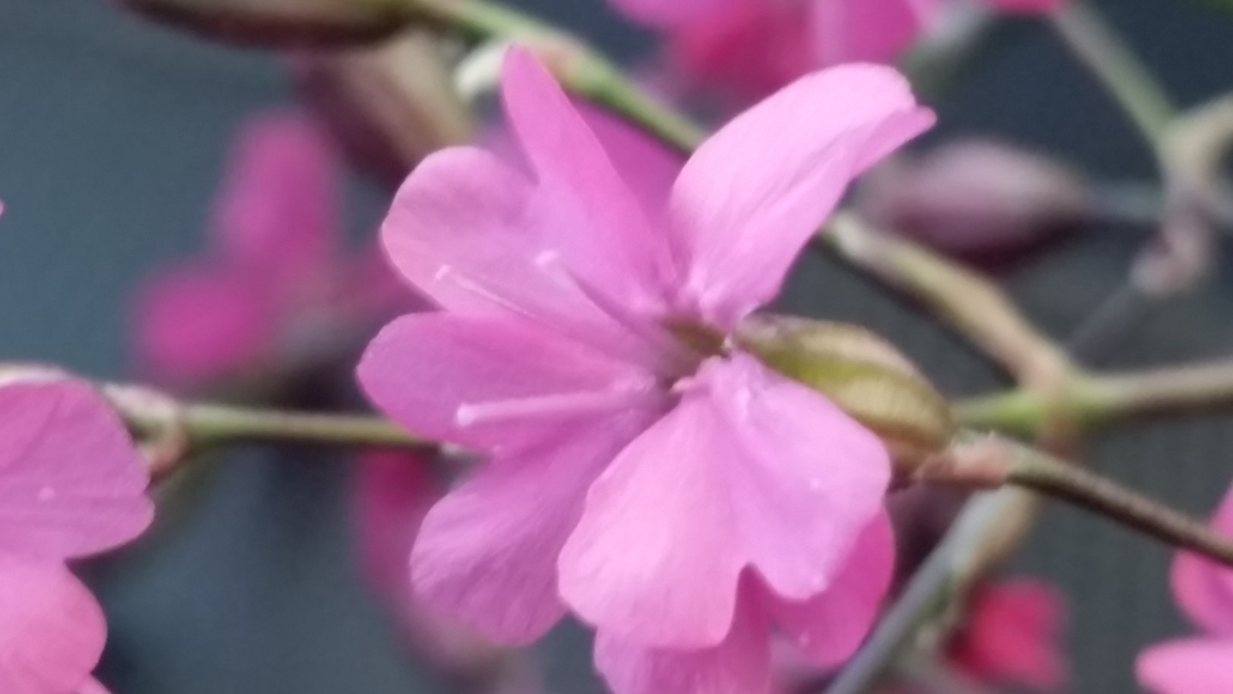
Figure 13. Silene magenta, flower, Ş. Yıldırımlı 43367 & Ö. Kılıç (holotype)

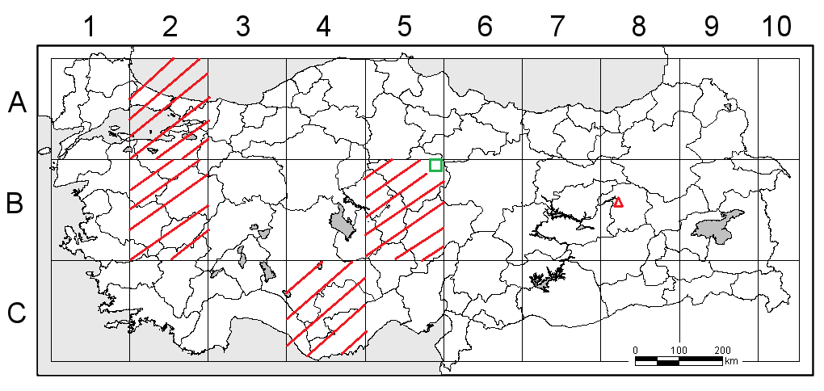
Figure 14. The distribution of Silene magenta close to S. hamzaoglui and S. phyrigia in Turkey

: Silene magenta : S. hamzaoglui : S. phyrigia

References

- GREUTER W., Silene L. (Caryophyllaceae) in Greece: a subgeneric and sectional classifi cation., Taxon, 44: 543-581, 1995.

- COODE MJE., CULLEN J., Silene L. In: Davis PH (ed.), Flora of Turkey and the East Aegean Islands, Edinburgh: Edinburgh Univ Press. Vol. 2, 179-242, 1967.

- DAVIS PH., MİLL RR., TAN K., Silene L. In: Davis PH, Mill RR & Tan K (eds.), Flora of Turkey and the East Aegean Islands, Edinburgh: Edinburgh Univ Press.Vol. 10 (Suppl. 1), 76-81, 1988.

- GREUTER W., Silene L. (Caryophyllaceae) in Greece: a subgeneric and sectional classifi cation, Taxon., 44, 543-581, 1995.

- AYTAÇ Z., Anew species of Silene (Caryophyllaceae) from Anatolia (Turkey). Thaiszia J.of Bot., 8, 7-11,1998.

- TAN K., VURAL M., Silene L. In: Güner A, Özhatay N, Ekim T & Başer KHC (eds.), Flora of Turkey and the East Aegean Islands, Edinburgh: Edinburgh Univ Press.Vol. 11 (Suppl. 2), pp. 50-53, 2000.

- VURAL M., DÖNMEZ A.A., Two new taxa of Silene (Caryophyllaceae) from Turkey, Annales Bot. Fennici., Vol. 39, 2, 153-158, 2002.

- DURAN A., MENEMEN Y., A new species of Silene (Caryophyllaceae) from South Anatolia, Turkey. Bot J Linn Soc., 143: 109-113, 2003.

- AYTAÇ Z., DUMAN H., Six new species Caryophyllaceae from Turkey. Annales Bot. Fennici., 41, 2, 213-223, 2004.

- DENİZ İG., DÜŞEN OD., Silene sumbuliana (Caryophyllaceae), a new species from SW Anatolia, Turkey. Annales Bot. Fennici., 41, 293-296, 2004.

- ÖZGÖKÇE F., TAN K., STEVANOVİÇ V., A new subspecies of Silene acaulis (Caryophyllaceae) from Turkey. Annales Bot. Fennici., 42, 143-149, 2005.

- ÖZHATAY N., KÜLTÜR S., Check-list of additional taxa to the supplement flora of Turkey III. Turk J Bot., 30, 281-316, 2006.

- BAĞCI Y., UYSAL T., ERTUĞRUL K., DEMİRELMA H., Silene kucukodukii sp. nov. (Caryophyllaceae) from south Anatolia, Turkey. Nord J Bot., 25, 306-310, 2007.

- GENÇ GE., KANDEMİR A., GENÇ İ., A new species of Silene (Caryophyllaceae) from east Anatolia, Turkey. Nord J Bot., 25, 58-63, 2007.

- BAĞCI Y., A new species of Silene L. (Caryophyllaceae) from South Anatolia, Turkey. Turk J Bot., 32, 11-15, 2008.

- TUGAY O., ERTUĞRUL K., A new species of Silene (Caryophyllaceae) from east Anatolia, Turkey. Bot J Linn Soc., 156, 463-466, 2008.

- AKSOY A., HAMZAOĞLU E., KILIÇ S., A new species of Silene L. (Caryophyllaceae) from Turkey. Bot J Linn Soc., 158, 730-733, 2008.

- ÖZHATAY N., KÜLTÜR Ş., ASLAN S.,Check-list of additional taxa to the Supplement Flora of Turkey IV. Turk J Bot., 33, 191-226, 2009.

- KANDEMİR A., GENÇ GE., GENÇ İ., Silene dumanii (Caryophyllaceae), a new species from East Anatolia, Turkey. Ann Bot Fenn., 46, 71-74, 2009.

- YILDIZ K., DADANDI MY., Silene cirpici (Caryophyllaceae), a new species of from Turkey. Ann Bot Fenn., 46, 464-468, 2009.

- BUDAK Ü., Murat K., Silene hamzaoglui (Caryophyllaceae), a new species from Çekerek (Yozgat, Turkey), Turk J Bot., 35, 285-289, 2011.

- FIRAT M., YILDIZ K., Silene miksensis (Caryophyllaceae), a new species from eastern Anatolia, Phytotaxa, 273, 4, 283–292, 2016.

